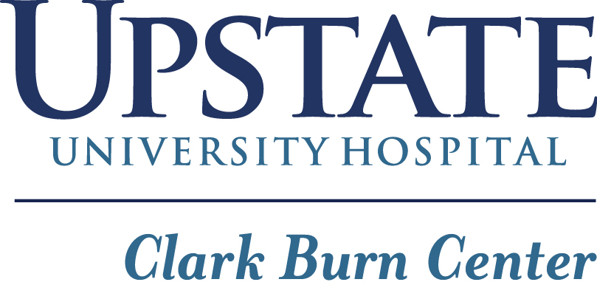
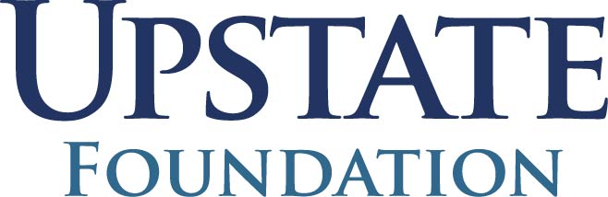
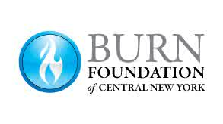

Hello!

Thank you for your interest in volunteering at Camp Triumph! Camp Triumph is a 4-day, 3-night camp, specifically for pediatric burn survivors, ages 5-18 years old. This camp is sponsored completely by the Burn Foundation of Central New York and the Upstate University Hospital Clark Burn Center Foundation; there is no cost to the campers or counselors to attend. All counselors are volunteers that are: adult burn survivors, first responders, supporters or hospital personnel.

This year, camp will take place from August 17th-20th^{d} at Beaver Camp, Lowville, NY.

For more information on the location visit: https://beavercamp.org.

Print out Proof of Negative PCR Covid test from 3 days prior, is required to attend camp.
An on-site quick Covid test will be done at the fire station.

Camp will kick off with a breakfast cooked by the fireman at Syracuse Fire Station 1 at 900 S. State Street, Syracuse 13202. The Campers and some of the counselors will be transported from there to Beaver Camp by bus. If you are one of the counselors riding the bus, please meet the bus at the East Syracuse Fire station located at 148 Saunders Creek Parkway, East Syracuse 13057 by 7:30am. You can leave your car at the East Syracuse Fire for the duration of camp. If you have previously arranged to drive separately, please meet us at the Syracuse Fire Station 1 by 8am for breakfast.

We will be returning to Syracuse on Sunday August 20th to the East Syracuse Fire station located at 148 Saunders Creek Parkway, East Syracuse 13057 around noon.

Some campers and counselors will be doing a Sleepover at the East Syracuse Fire station Wednesday night August 16th.

Enclosed, you will find more information regarding our code of conduct for counselors at Camp Triumph, as well as forms that will need to be completed and returned, by August 1st. Please include on the forms the most convenient way to contact you.

If you have any questions, feel free to contact:

Jay or Judy Tinker via email cnyburncamp@gmail.com or by phone 315/696-8274

On behalf of Camp Triumph Staff, The Burn Foundation of CNY, Upstate University Hospital Clark Burn
Center & Foundation, we look forward to seeing you soon!

