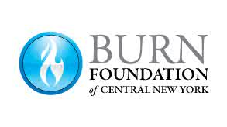

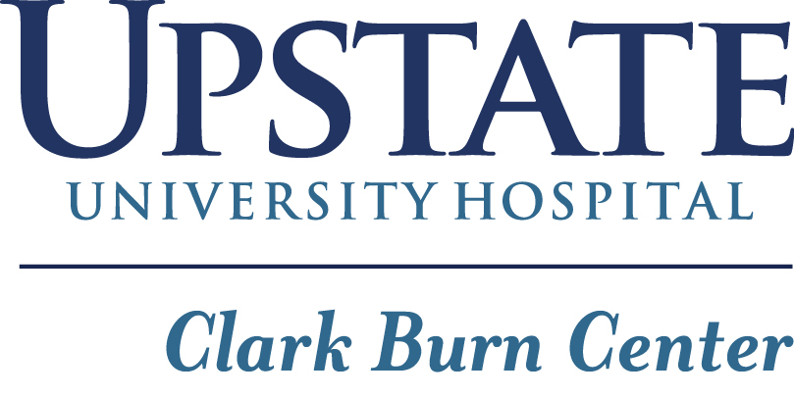

AGREEMENT AND RELEASE

Covering all activities (i.e. Camp Triumph, Holiday Party, etc.) carried out by The Burn Foundation of CNY and its affiliates for the January1st 2023 through December 31st 2023.
In consideration of the Burn Foundation of CNY, undertaking Camp Triumph and youth programs to benefit the health and welfare of the participant (hereinafter called "Camper") and activities incidental thereto, including transportation to and from Camp Triumph and various other activities at the request of the undersigned acting on behalf of the camper's parents or guardians, the undersigned agrees, represents and certifies as follows:

- The undersigned is a parent or legal guardian of the Camper or has full and complete authority from all parents or legal guardians of the Camper to execute this agreement on behalf of said parents or legal guardians.

- It is recognized that the Camper's participation in Camp Triumph program mentioned above and related activities involves risk of bodily injury and property loss and damage incidental to such type of activities, and it is agreed that the risk of any such injury, loss or damage is assumed by the Camper and all of the Camper's parents or legal guardians.

- The undersigned and all of the Camper's parents or legal guardians individually and as such parents or guardians, hereby waive, remise, release and forever discharge the Foundation and its respective officers, agents, employees and representatives, of and from all liability, claims or demands for damages whatsoever, except for those resulting from recklessness or willful misconduct, on account of personal injury to the Camper or loss or damage to the Camper's property resulting from, participation in the above mentioned activities, including the "2022 session of Our Annual Youth Summer Camp': including by way of illustration but not limitation, injury, loss or damage occurring during (i) travel to and from the . camp; (ii) activities held therein; (iii) overnights and meals, (iv) rest and waiting periods. The undersigned and all the Camper's parents or legal guardians further hereby agree to hold harmless and to indemnify and defend the aforesaid Foundation and its respective officers, agents, employees and representatives, from and against any claims, loss, damage, cost, or expense including reasonable attorney's fees, that may be incurred as a result of any such action, claim or demand except for those based upon acts of recklessness or willful misconduct.

- The Foundation is hereby instructed and authorized to employ such emergency medical treatment as they see fit during the Camper's participation in any of the above mentioned activities, if, in their sole judgment, the condition of the Camper, because of injury, illness or otherwise, requires such emergency treatment, and the Association and its respective officers, agents, employees and representatives, are hereby remised, released, and forever discharged by the undersigned and all of the Camper's parents or legal guardians from any liability for all their decisions and actions, made and done in good faith, in administering such emergency medical treatment.

- By signing this Agreement and Release the undersigned hereby acknowledges and represents that he and/or she has read and understands (1) each of the provisions contained herein, and (2) the activities in which the Camper will participate during the camp program.

Camper Name: __________________________________________
(please print name)

Dated: ___________________

Parent or
Legal Guardian: ___________________________ __________________________
(Signature) (please print name)

Witness: ___________________________ __________________________
(Signature) (please print name)

