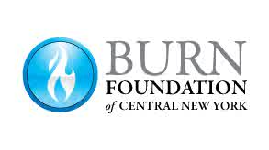

Motorcycle Riding Release

This year Camp Triumph participants will have the opportunity to receive a Motorcycle ride on private camp roads. The cycle will be operated by an experienced Biker and safety helmets will be worn during the ride. At no time will the cycles be used in an unsafe manor, rode at high rates of speed or driven on Public roads.

Any camp participant without a signed release, will be able to see and talk with the Bikers, but will not be given a ride.

I, the undersigned, hereby agree, in entering Motorcycle riding, to forever release and discharge the Motorcycle club, their personnel, all other participants and all property owners whose property I may ride on or pass, from any and all loss whatsoever, which may arise out of this camp activity.

I fully understand the dangers of Motorcycle riding being that conditions can be unpredictable and hold no one responsible for any damage or injury to either myself or my driver should any unfortunate injury be forthcoming.

I am signing below fully understanding this liability waiver, that Motorcycle riding can be a high-risk activity, and holding no one responsible for any injury to myself/my child while at camp.

I am attending a Camp Triumph on dates: ______________________

Participant’s name: _______________________________________
Please print

Participant’s Signature: ____________________________________ Date: ___________________

Minor’s Parent/Guardian name: _______________________________________
Please print

Minor’s Parent/
Guardian Signature: _______________________________________ Date: ___________________

